Vision Statement – Iroquois School Counseling Program

Welcome to the Iroquois MS/HS Webpage
The purpose of the Iroquois School system is to provide a positive growth and learning experience for the children of this community in a safe, caring, and consistent atmosphere, with due consideration being made to the rural culture and history in both the construction of the curriculum and our teaching practices. Our human material resources are totally dedicated to preparing our students for meaningful adult experiences by stressing physical, emotional, academic, and social development.
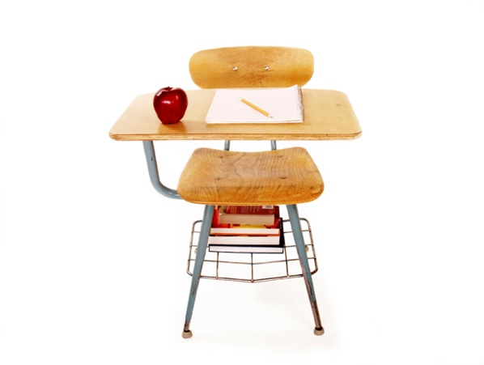
The main objective of the Iroquois School District is to prepare students academically, emotionally, and socially so that they will become responsible members of society and can live successfully in the present-day world.
The school program must be relevant so that students will appreciate their heritage and will be able to evaluate society and their place in that society. It must enrich the individuals in Arts and Sciences. It must prepare students for a world of work as well as the world of leisure.
The role of the Iroquois School District must extend to the areas of moral, ethical, and spiritual concerns as it is necessary to supplement the training given by home, church, and community in developing desirable attitudes and values.
The school must be active in the area of public relation as it should and rightfully so, expect the cooperation and understanding of a well-informed community.
The aim of the Iroquois School District is to provide and maintain the best possible facilities and personnel in order to attain the desired objectives.

